Software Requirements Specification

for

EMU Student Kit

Version 1.1 approved

Prepared by GROUP 2

CMSE322, EMU, Cyprus.

Apr 29, 2017

Table of Contents

Table of Contents ii

Revision History iiii

1. Introduction 1

1.1 Purpose 1

1.2 Document Conventions 1

1.3 Intended Audience and Reading Suggestions 1

1.4 Product Scope 1

1.5 References 2

2. Overall Description 2

2.1 Product Perspective 2

2.2 Product Functions 2

2.3 User Classes and Characteristics 3

2.4 Operating Environment 4

2.5 Design and Implementation Constraints 4

2.6 Assumptions and Dependencies 4

3. External Interface Requirements 5

3.1 User Interfaces 5

3.2 Hardware Interfaces 5

3.3 Software Interfaces 5

3.4 Communications Interfaces 6

4. System Features 6

4.1 System Feature 1: Timetables 6

4.2 System Feature 2: Calendar 6  
4.3 System Feature 3: Bus Schedule 7  
4.4 System Feature 4: News 8  
4.5 System Feature 5: Notes 8  
4.6 System Feature 6: Info 9  
4.7 System Feature 7: GPA 9  
4.8 System Feature 8: Settings 10  
4.9 System Feature 9: Tasks 11

5. List of Functional Requirements 12

5.1 User Requirements 12

5.2 Admin Requirements 13

5.3 System Requirements 14

6. Other Nonfunctional Requirements 16

6.1 Performance Requirements 16

6.2 Safety Requirements 16

6.3 Security Requirements 16

6.4 Software Quality Attributes 16

7. Other Requirements 17

Appendix A: Glossary 17

Appendix B: Analysis Models 18

Appendix C: To Be Determined List 20

**Revision History**

|  |  |  |  |
| --- | --- | --- | --- |
| **Name** | **Date** | **Reason For Changes** | **Version** |
| ADHAM | 29/04/17 | Diagrams, References, Format and Requirements. | 1.1 |

# Introduction

## Purpose

This project was started due to shortage of productivity and organizational applications that are specifically designed for students. Since there are over 20,000 students in EMU, this project aims to improve the performance and time management of students, give them useful information about the University, assist them during lectures, and provide many other beneficiary features for students.

## Document Conventions

This document follows MLA Format. Bold-faced text has been used to emphasize section and sub-section headings. Highlighting is to point out words in the glossary and italicized text is used to label and recognize diagrams.

## Intended Audience and Reading Suggestions

This document is to be read by the development team, the project managers, marketing staff, testers and documentation writers. The SRS has been organized approximately in order of increasing specificity. The developers and project managers need to become intimately familiar with the SRS.

Others involved need to review the document as such:

**Overall Description** – Marketing staff have to become accustomed to the various product features in order to effectively advertise the product.

**System features** – Testers need an understanding of the system features to develop meaningful test cases and give useful feedback to the developers.

## Product Scope

The EMU Student Kit is a complex multi-functional Android Mobile Application designed for EMU with a variety of different functions and features that are beneficiary for students. This application can also be used by any other student and not only EMU students.

## References

[1] *Android 4.4 Kit-Kat, Android. Retrieved 29 April 2017, from*  
 <https://www.android.com/versions/kit-kat-4-4/>

[2] *EMU’s Interactive Google Map, EMU. Retrieved 29 April, from*  
 <https://ww1.emu.edu.tr/campusmap?design=empty>

[3] *Google Drive, Google. Retrieved 29 April, from*  
 <https://www.google.com/drive/>

[4] *SRS Document Figure 4, Use Case Diagram*.

[5] *Flowchart Maker & Diagramming Software, Microsoft. Retrieved 1 May 2017, from*  
 <https://products.office.com/en-us/visio>

# Overall Description

## Product Perspective

The software product being developed is for portable mobile devices with Android operating system with a minimum version of API 19 Android 4.4 Kit-Kat [1]. Portable mobile devices should be equipped with a microphone, a camera, a touch screen and a fully functional network adapter. An internet connection is needed for synchronization and updates, either through WIFI or 3G/Cellular

## Product Functions

The EMU Student Kit is a complex project designed to help students with their daily university life, either by organizing their study life or introduce the students to a wide range of activities near them. Some proposed functionalities of the application are as follows:

**1. Lectures Schedule and time-table:**

- Input Utility.

- Auto-extraction of data such as the courses, exams, instructors time tables from the portal xml  
 page.

- University Calendar events (‘exams – Holidays – Other Activities’).

- Notifications and Reminders for upcoming lectures, events, exams, etc.

**2. Map:**

- Campus interactive map. [2]

- Includes campus facilities (‘Departments – Stadiums – Activity Centers’).

- Shows the classrooms and other areas of interest on the map.

- Classrooms search on the map.

- Up to date Bus Schedules.

**3. Security, Reliability and other features:**

- Encrypted app with PIN/Password based system.

- May include cloud backup using existing services ex. (‘Google Drive [3]- Drive One’).

- GPA & CGPA Calculator

- News of university/department with notifications.

- Recording, photo and note taking during a lecture.

**4. In-app user manual** (Help page).

## User Classes and Characteristics

**2.3.1 Customer:**

Customers for this particular product are university students. Students most frequently use the application for organizing and assisting their university life, all the way from lectures, exams and tasks through their campus and social life. The customers are not expected to have a high educational and proficiency level or technical expertise. Hence, the user interfaces are available in English language only.

**2.3.2 Administrator:**

Administrators are expected to have appropriate experience in such field. He/She has the privilege to edit, add and delete contents in some parts of the application, those parts include:

-Edit calendar.

-Modify bus schedule.

-Update info.

According to the *use-case diagram* [4]

**2.3.3 Testers:**

Software testers are expected to have appropriate experience in the testing field, and should carry out multiple testing strategies to test all aspects of the program throughout the development stage as well as after the program is released. Bugs and malfunctions should be reported back to programmers with appropriate alternative scenarios.

## Operating Environment

The software will operate under the following aspect:

The application being developed will be running under a minimum embedded operating system of API 19 Android 4.4 Kit-Kat.

The minimum Hardware requirements that will be running the application is as follows:

-200 MHz Processor  
-512 MB of RAM  
-50 MB of storage

-CPU architecture of ARMv5 or higher

For more information about hardware specifications, refer to section 3 of this document.

## Design and Implementation Constraints

1. Synchronization: Uses WIFI or 3G to connect to the database.

2. Memory: Mobile devices are advised to have a minimum of 2GB free storage, as students might want to save lecture notes, photos and voice recordings. Software and database cannot exceed this amount. Software must be able to read and write to mobile phones with SD card slots.

3. Language requirements: software must be in English language.

## Assumptions and Dependencies

It is assumed that the application will work correctly with any mobile device with Android OS version 4.4 and above. Because the device acquires database and other updates using internet connection. Mobile devices should have a working WIFI adapters and/or 3G network connection.

# External Interface Requirements

## User Interfaces

The EMU Student Kit’s user interface has been specifically designed with students in mind, giving them convenience in their educational and personal university life. The EMU student Kit makes sure at every point, that students spend most of their times using the application rather than figuring out how to use it.

The user should be presented with a login page after starting the application, which will prompt the user to input a 4-digit passcode to unlock the application and move to the home screen.

The home screen offers a grid view menu with a list of functions that the device performs. The user can select one of the options on the menu and is taken to the respective screen.

For more information on UI requirements, please refer to section 4.

## Hardware Interfaces

The EMU Student Kit application, has many features that uses the hardware of the mobile device, as described in section 4, those features should include:

Users have the option to take photos and save them to the SD card under a label of the lecture.  
Users have the option to take voice notes and save the to the SD card under a label of the lecture.

The only way to synchronize the application and update its contents is through internet connection, whether through WIFI or 3G.

The application also uses GPRS connection to show location of the lectures and points of interest.

## Software Interfaces

The EMU Students Kit has been specifically designed as an Android Application and can only be run on Android embedded OS with API version 19 (aka) Android 4.4 Kit-Kat and above. The application uses a Local Resources DB, Local User DB and Online DB.

## Communications Interfaces

Users can connect their device to their database using an internet connection, whether through WIFI or 3G. Once connected to the database, the application synchronizes and updates itself. The update should not take any longer than 10 minutes.

# System Features

## View/Modify Timetables

### Description and Priority

The user will be able to select from multiple timetables, including exam timetable, lectures timetable and professors timetable. This feature has a high priority as it is one of the main features and functionalities of the application.

### Stimulus/Response Sequences

From the home page of the application, a menu will appear, one of the menu items is timetable, after the user selects this item, the application should travel to the timetable page, which also contains a drop down menu at the top of the page, which the user can use to navigate through different timetables.

### Functional Requirements

* REQ1-1: The user should be able to add, edit and delete his timetable.
* REQ1-2: The user should be able to add, edit and delete his exams timetable.
* REQ1-3: The timetables page should contain drop down menu to select “My timetable”, “Instructor timetable” and “Exams timetable”.

## View Calendar

### Description and Priority

The user will be able to view all academic calendars appointed by the university for the current academic year. The academic calendar will be synchronized from the university’s website and store on the mobile device, This feature has a high priority as students need to get their hands on the academic calendar throughout the academic year.

### Stimulus/Response Sequences

From the Home page, the user will be able to click on “calendar” menu title which will navigate him to another page that includes all available calendars.

### Functional Requirements

* REQ2-1: The user should be able to choose and view the desired calendar from the list of calendars appointed by the application.
* REQ2-2: The admin should be able to add, edit and delete events in the academic calendar.

## Display Bus Schedule

### Description and Priority

The user should be able to view all bus schedules and their maps through the “Bus Schedule” page, which is also presented as a menu title in the home page.

### Stimulus/Response Sequences

From the home page, the user selects “Bus Schedule” and it should direct him to the Bus Schedule page which contains all schedules and routes for EMU’s bus services.

### Functional Requirements

* REQ3-1: The user should be able to view and navigate through bus routes and schedules in the “Bus Schedule” page.
* REQ3-2: The admin should be able to add, edit and delete bus schedules.

## Show EMU News

### Description and Priority

The user should be able to view headlines of news presented in EMU’s website as RSS feed, the application should show the RSS feed in the appropriate layout, and should be synchronized and updated regularly with EMU’s website news section. Photos, Videos and links should be compatible in this page.

### Stimulus/Response Sequences

From the home page, the user selects “News” and it should direct him to the News page.

4.4.3 Functional Requirements

* REQ4-1: The user should be able to view headlines and latest university feed and news in the “News” page.
* REQ4-2: The admin should be able to add, edit and delete RSS feed in the news page.
* REQ4-3: The news page should contain RSS feed up to date with new tab in EMU’s website.

## Display/Edit Notes

### Description and Priority

In the “Notes” page, the user should be able to add lecture notes, that might include pictures and voice recordings, the user should be able to edit and view current notes as well.

### Stimulus/Response Sequences

From the home page, the user should be able to click on “Notes” menu title, and navigate directly to the notes page, where he can view current notes, edit them or add new notes.

### Functional Requirements

* REQ5-1: The user should be able to add, edit and delete text in the notes page.
* REQ5-2: The user should be able to add, edit and delete pictures in the notes page.
* REQ5-3: The user should be able to add, edit and delete voice recordings in the notes page.
* REQ5-4: The notes page should contain an applicable interface to input notes, pictures and voice notes for the selected course.
* REQ5-5: the quick add button should open a menu to quickly add notes

## Show information about University

### Description and Priority

In the “Info” page the user should be able to view information about the university, points of interest on campus and off campus, emergency hotlines as well as telephone numbers of some taxi drivers and airport transport services. The page also includes opening hours of mentioned points of interest.

### Stimulus/Response Sequences

From the home page, the user can get to the “Info” page after clicking if the Info menu title.

### Functional Requirements

* REQ-1: The user will be able to view Info about points of interest in the info page.
* REQ-2: The user will be able to view telephone numbers of emergency services in Famagusta.
* REQ-3: The user will be able to view telephone numbers of various taxi agencies and other transportation agencies.
* REQ-4: The admin should be able to add, edit and delete phone numbers in info page.
* REQ-5: The admin should be able to add, edit and delete office hours in information page.

## Calculate GPA/CGPA

### Description and Priority

The application should have a fully functional built-in GPA/CGPA calculator under GPA Calculator page. The user should be able to add courses, credit hours and the grade acquired, in which the application would calculate his current GPA. The user might also calculate his CGPA by providing the information required.

### Stimulus/Response Sequences

The user can navigate to the GPA calculator page, through the home screen, after the user clicks on the menu title “GPA Calculator” the user will be prompt to enter the Course, Credit hours and the grade acquired, the grade acquired should be selected using a drop down menu. After adding all course, the user should see a calculate button underneath, in which after interacting with the application calculates the GPA.

### Functional Requirements

* REQ7-1: The user should be able to input current grades and calculate GPA/CGPA in GPA Calculator page.
* REQ7-2: The GPA Calculator should use the algorithm used by EMU in calculating GPA’s.
* REQ7-3: If the user inputs a wrong value, the applications should show an error pop up message.

## Settings

### Description and Priority

The application provides multiple settings for the user to make use of, the user can add or change his lock pin, choose desire notification time frame, change the background of the application, choose the color theme of the application and choose what notifications the user wants to receive through the settings page.

### Stimulus/Response Sequences

The settings page can be reached from the home page, after the user clicks on “Settings” menu title. In the settings page, the user will be able to view and choose what settings option the user wants to view/edit.

### Functional Requirements

* REQ8-1: The user should be able to add or change the applications lock pin through the settings page.
* REQ8-2: The user should be able to choose the desired notifications time frame through the settings page
* REQ8-3: The user should be able to choose the background of the application through the settings page.
* REQ8-4: The user should be able to choose the color theme of the application through the settings page.
* REQ8-5: The user should be able to choose what notifications he wants to receive through the settings page.
* REQ8-6: The admin should be able to add, edit and delete settings options.
* REQ8-7: The settings page should contain button links to the pages: about, help and contact us.
* REQ8-8: The settings page should contain the option to change the login page.
* REQ8-9: The settings page should contain the option to change the theme color of the application.
* REQ8-10: The settings page should contain the options to change the background of the application.
* REQ8-11: The help page should contain easy and user friendly steps to use the application.
* REQ8-12: The contact us page should contain a mailto:// link to the admin.
* REQ8-13: The about page should contain the description of the application as well as the version of the application.

## Tasks

### Description and Priority

In the tasks page, the user will be able to add, edit and delete tasks, as well as marking complete tasks, students may use this page to input tasks and set reminders for deadline dates and times, in which the application will send a reminder notification if applicable.

### Stimulus/Response Sequences

Through the home page, the user might select tasks from the title menu to navigate to the tasks page. Or by clicking on the quick add button presented in the home page, he will be able to add tasks on the run. The user might also assign reminders and deadlines for the task through the Tasks page.

### Functional Requirements

* REQ9-1: The tasks page should contain task the student has assigned for courses.
* REQ9-2: The tasks page should contain a drop down menu to group tasks by course.
* REQ9-3: Each task in tasks page should contain a checkbox to mark when done.
* REQ9-4: the quick add button should open a menu to quickly add tasks.

# List of Functional Requirements.

## User Requirements:

R1.1: The user should be able to add, edit and delete his timetable.

R1.2: The user should be able to add, edit and delete his exams timetable.

R1.3: The user should be able to add, edit and delete courses.

R1.4: The user should be able to add, edit and delete text in the notes page.

R1.5: The user should be able to add and delete pictures in the notes page.

R1.6: The user should be able to add and delete voice recordings in the notes page.

R1.7: The user should be able to add or change the applications lock pin through the  
 settings page.

R1.8: The user should be able to choose the desired notifications time frame through the  
 settings page.

R1.9: The user should be able to choose the background of the application through the  
 settings page.

R1.10: The user should be able to choose the color theme of the application through the  
 settings page.

R1.11: The user should be able to choose what notifications he wants to receive through  
 the settings page.

R1.12: The user should be able to input current grades and calculate GPA/CGPA in GPA  
 calculator page.

R1.13: The user should be able to send direct messages, and complaints to the admin through the  
 contact us page.

R1.14: The user should be able to navigate to the desired page through the main menu.

R1.15: The user should be able to view the user manual in help page.

## Admin Requirements:

R2.1: The admin should be able to add, edit and delete events in the academic calendar.

R2.2: The admin should be able to edit the interactive map’s locations and places of interest.

R2.3: The admin should be able to add, edit and delete the bus schedules.

R2.4: The admin should be able to add, edit and delete phone numbers in the information page.

R2.5: The admin should be able to add, edit and delete office hours in information page.

R2.6: The admin should be able to add, edit and delete RSS feed links in the news page.

R2.7: The admin should be able to add, edit and delete contents in the help page.

R2.8: The admin should be able to add, edit and delete contents in the about page.

R2.9: The admin should be able to add, edit and delete contents in the contact us page.

R2.10: The admin should be able to add, edit and delete settings options.

## System Requirements

R3.1: The user should be able to see and interact with a login page with a pin lock prompt when  
 opening the application.

R3.2: The home page should contain buttons linked to the following pages:

|  |  |  |
| --- | --- | --- |
| Timetables | Calendar | Map |
| Bus Schedule | News | Notes |
| Info | GPA Calculator | Tasks |
| Settings | Quick add |  |

R3.3: The timetables page should contain a drop down menu to select “My timetable”, “Instructor  
 timetable” and “Exams timetable”.

R3.4: The calendar page should contain a drop down menu to select different academic  
 calendar.

R3.5: The map page should contain a similar interactive map to that on EMU’s website.

R3.6: The bus schedule page should contain bus schedules as well as bus route maps.

R3.7: The news page should contain RSS feed up to date with news tab in EMU’s website.

R3.8: The notes page should contain an applicable interface to input notes, pictures and voice  
 notes for the selected course.

R3.9: The info page should contain phone numbers, opening hours and announcements for   
 points of interest in the university campus.

R3.10: The info page should contain emergency phone numbers in TRNC.

R3.11: The GPA calculator page should contain an offline GPA and CGPA calculator for students  
 to use.

R3.12: The tasks page should contain task the student has assigned for courses.

R3.13: The tasks page should contain a drop down menu to group tasks by course.

R3.14: Each task in tasks page should contain a checkbox to mark when done.

R3.15: The settings page should contain button links to the pages: about, help and contact us.

R3.16: The settings page should contain the option to change the login page.

R3.17: The settings page should contain the option to change the theme color of the application.

R3.18: The settings page should contain the options to change the background of the  
 application.

R3.19: The about page should contain the description of the application as well as the version  
 of the application.

R3.20: The help page should contain easy and user friendly steps to use the application.

R3.21: The contact us page should contain a mailto:// link to the admin.

R3.22: the quick add button should open a menu to quickly add tasks, notes, pictures and courses.

R3.23: Each page should contain a header banner that includes the page title.

R3.24: The system should show an error message if the user enters a wrong PIN.  
R3.25: The system should retry PIN after each wrong input.

R3.26: The system should proceed to the home page after PIN is matched with predefined PIN.

R3.27: The system should navigate to “Time Tables” page when clicked on.

R3.28: The system should navigate to “Calendar” page when clicked on.

R3.29: The system should navigate to “Map” page when clicked on.

R3.30: The system should navigate to “Bus Schedule” page when clicked on.

R3.31: The system should navigate to “News” page when clicked on.

R3.32: The system should navigate to “Notes” page when clicked on.

R3.33: The system should navigate to “Info” page when clicked on.

R3.34: The system should navigate to “GPA Calculator” page when clicked on.

R3.35: The system should navigate to “Settings” page when clicked on.

R3.36: The “Time Tables” page should contain a drop down menu at the top to choose from courses  
 and exams.

R3.37: The Courses Time Table should show week days as buttons.

R3.38: Each week day button should navigate the user to the rotational day calendar.

R3.39: Each course in the Courses Time Table page should contain the course title, start time and   
 end time.

R3.40: Clicking on a course shows a new page in which the user can edit the course title, date and  
 time. As well as add notes.

R3.41: Exams Time Table page should show pre-added exams and their dates, times, course title  
 associated and location of exam.

R3.42: The quick add button should be present in all pages of the system except the login page.

# Other Nonfunctional Requirements

## Performance Requirements

The application will use the performance requirements of Android Application (APK) standards for Android API Version 19 and above.

## Safety Requirements

The application should not contain any safety threats and malware to users.

## Security Requirements

* AES encryption.
* HTTPS Database encryption
* Application Login PIN.

## Software Quality Attributes

Adaptability, availability, correctness, flexibility, maintainability, portability, reliability, reusability, robustness, testability, and usability.

# Other Requirements

Requirements, may be added, edited or even deleted through the stages of design and development.

Appendix A: Glossary

SD – Secure Digital. A widely available format for flash memory cards.

USB – Universal Serial Bus. A serial bus standard that is used in many computer peripherals and other electronic devices.

Github – web-based Git or version control repository and Internet hosting service.

WIFI – a technology for wireless local area networking with devices based on the IEEE 802.11 standards

Google Drive – a file storage and synchronization service developed by Google

APK – Android Package Kit (APK) is the package file format used by the Android operating system for distribution and installation of mobile apps and middleware

DBA – Database administrators (DBAs) use specialized software to store and organize data.

PIN – **Personal Identification Number** (**PIN**) is a 4-digit**number** combination known only to you, and allows you to access your account information

3G – third generation of wireless mobile telecommunications.

GPRS – General Packet Radio Service (**GPRS**) is a packet oriented mobile data service on the 2G and 3G cellular communication system's global system for mobile communications (GSM).

Appendix B: Analysis Models

The following diagrams were made using Microsoft visio [5]

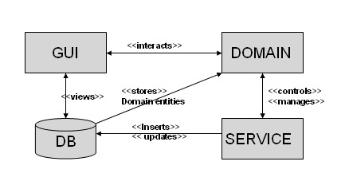Components Model

*Fig 1. Components of EMU Student Kit*

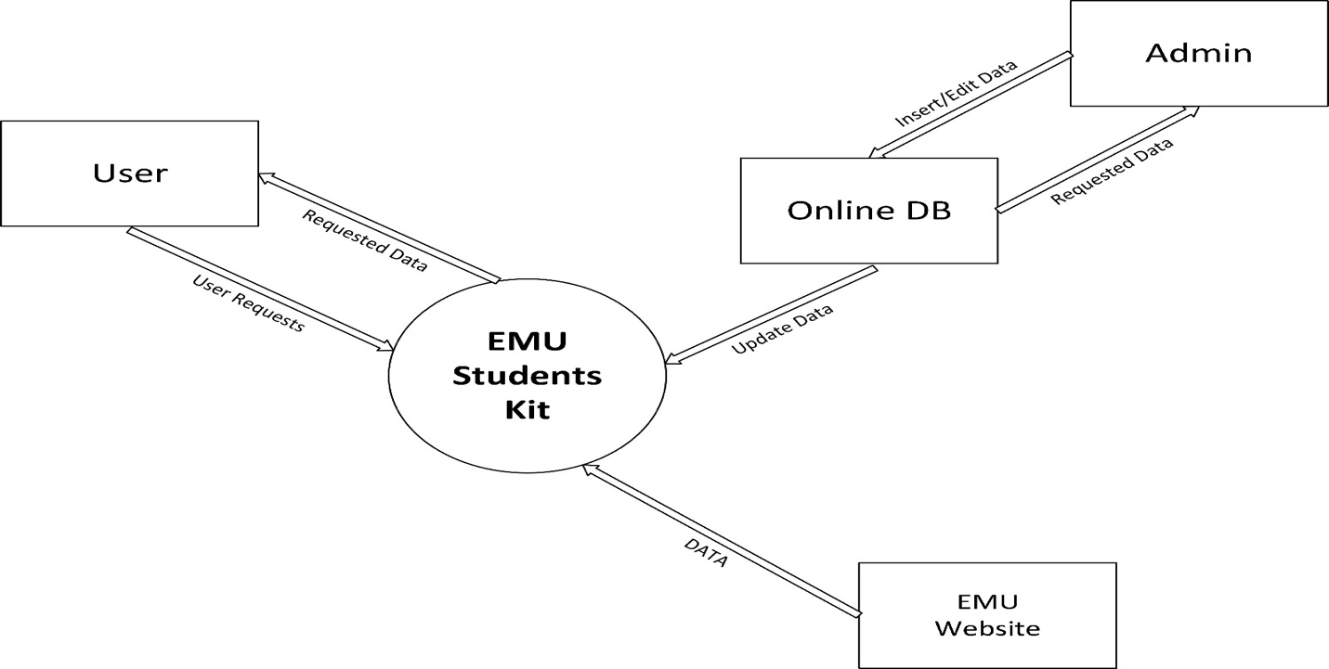Context Diagram

*Fig 2. Context Diagram*

Level 0 DFD

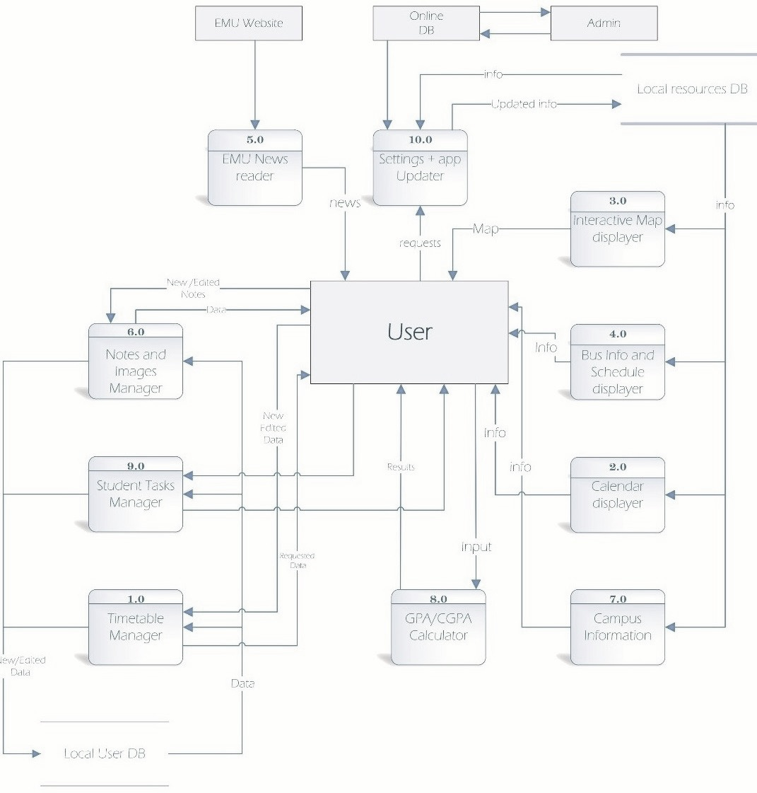

*Fig 3. Level 0 Data Flow Diagram*

Use Case Diagram

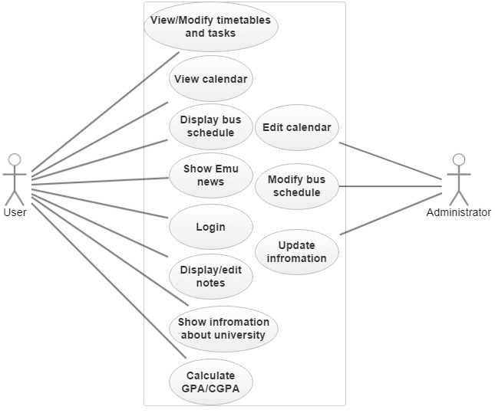

*Fig 4. Use Case Diagram*

Appendix C: To Be Determined List

Business rules.